**The results of RNA integrity with Agilent 5400 of four cell line.** x-axis: distribution of fragments in the capillary sample where the size (nt) reaction is located; y-axis: the real-time fluorescence (RFU) signal intensity of the sample in the process of capillary separation, the higher the RFU value, the higher the concentration of the sample.

K562:

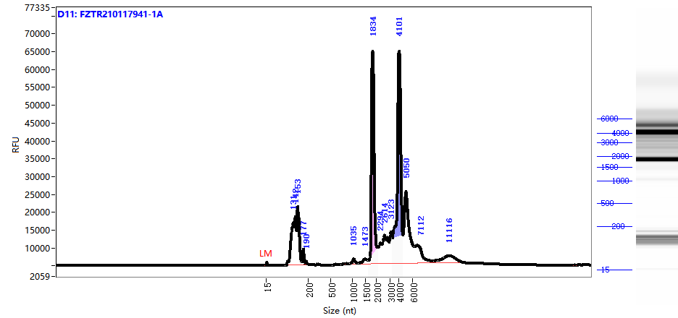

THP-1: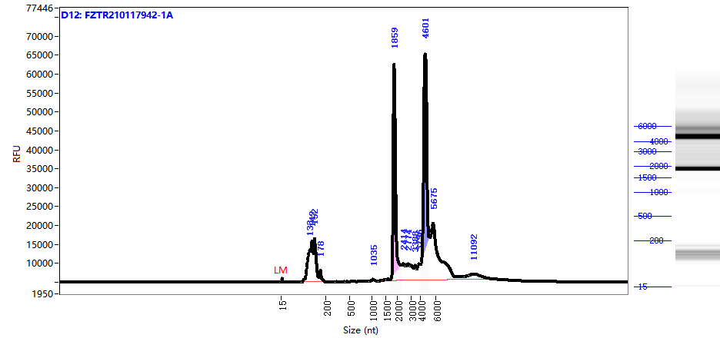

MOLM13:

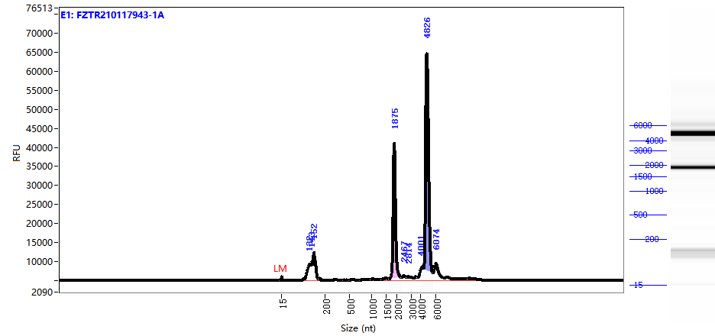

HL-60: